https://hk.news.yahoo.com/uniqlo%E9%99%8D%E5%83%B92%E6%88%90-%E6%8E%80%E6%99%82%E8%A3%9D%E5%BA%97%E6%B8%9B%E5%83%B9%E6%BD%AE-224518289.html

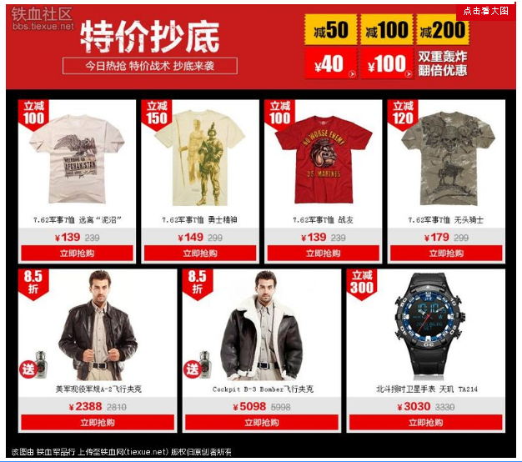http://bbs.tiexue.net/post_11459531_1.html

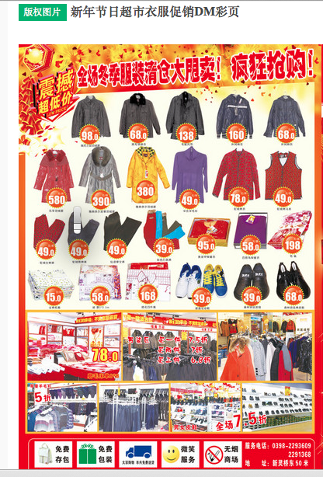

http://weili.ooopic.com/weili_14697521.html

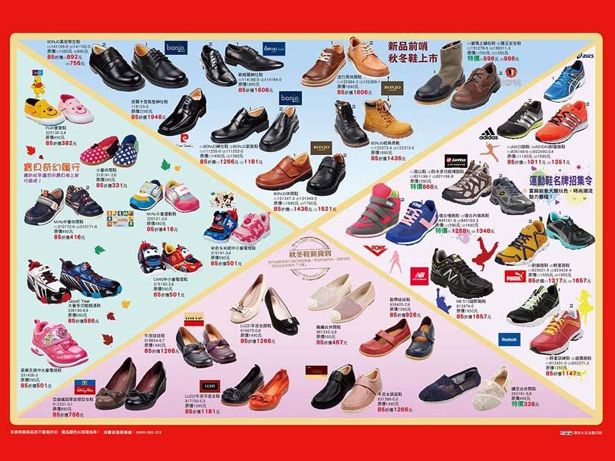

https://www.familyshoes.com.tw/Actions.aspx?p=11

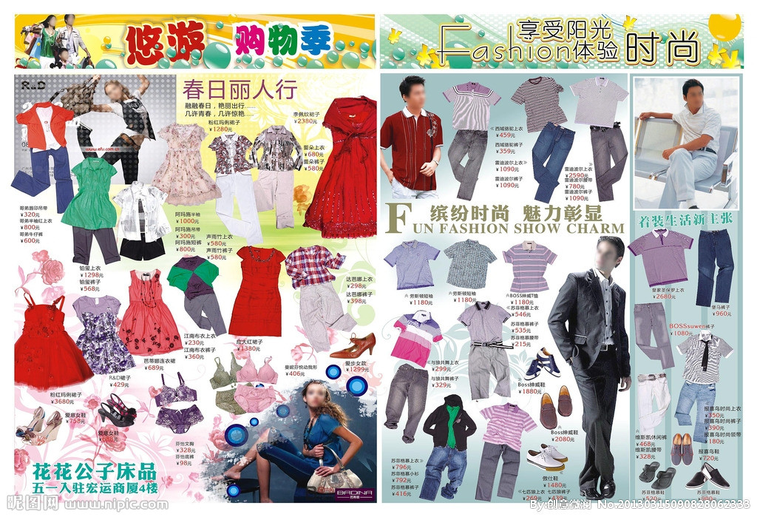
http://www.nipic.com/show/3/119/7673696k20cc280d.html

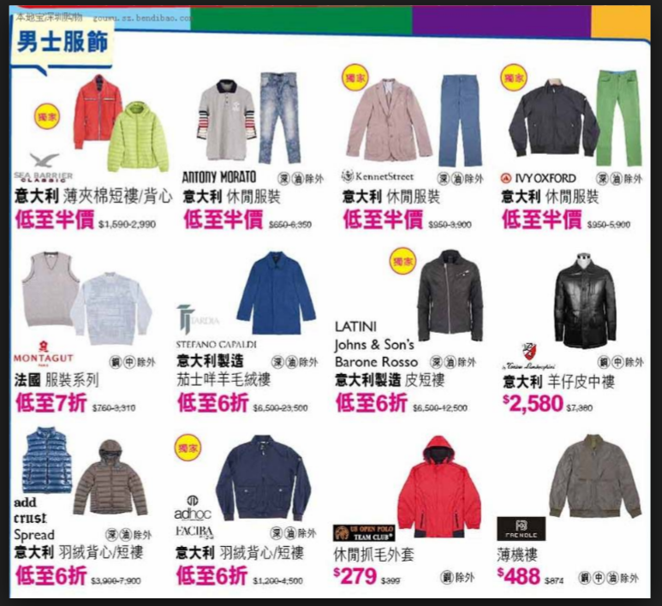
https://www.google.com/search?q=%E5%8F%B0%E6%B9%BE%E8%A1%A3%E6%9C%8D%E5%B9%BF%E5%91%8A&espv=2&biw=1455&bih=699&source=lnms&tbm=isch&sa=X&ved=0ahUKEwjukMSVs43OAhXDth4KHSGPBxUQ_AUIBigB#tbm=isch&q=%E8%A1%A3%E6%9C%8D%E5%A4%A7%E5%87%8F%E4%BB%B7&imgrc=VnMkQz5EwG2NGM%3A

